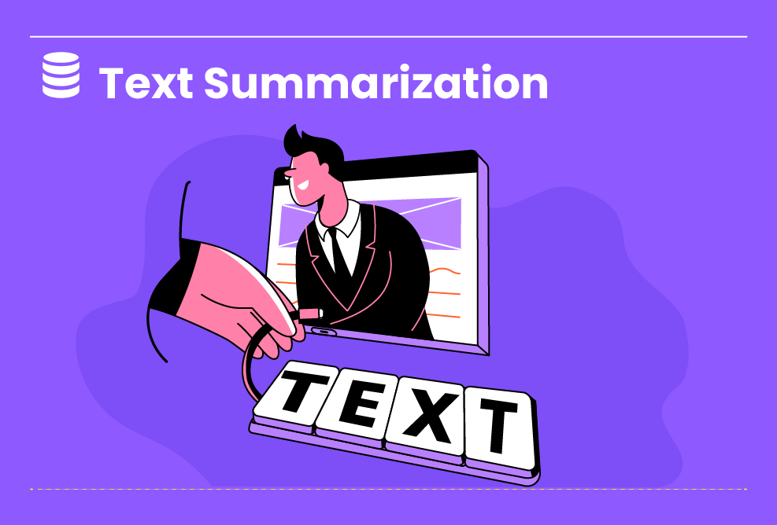

All Levels

**Abstractive Text Summarization using Transformer-BART Model**

Summarisation is crucial in many areas and finds plenty of use cases in everyday life. We are always onto the summary before the book, product, course, or looking for a college. Some professional experts write summaries, but not every time we need expert summaries for our products. Text Summarisation tools produce good quality jists in an a...

Duration : 10 Hours

All Levels

5 Steps

**Project Objective**

1. Develop an AI-powered chatbot that can respond accurately and be helpful to users' questions and inquiries. 2. Improve customer engagement and satisfaction by providing a fast, reliable, personalized chatbot response system. 3. Increase efficiency and productivity of customer service operations by automating common inquiries and freeing up human agents to focus on more complex issues.

**Inspiring Project Examples**

https://www.projectpro.io/project-use-case/text-summarization-transformers-bart-model

**Step By Step**

On this project, you will pass by these steps. All steps must be done to successfully complete this project.

**Data Preparation and Preprocessing**

The Data Is Collected And Preprocessed In This Phase To Remove Irrelevant Information And Noise. This Phase Involves Converting The Text Data Into Numeric Vectors That Can Be Fed Into The Pre-Trained Language Model. This Is Done Using Techniques Like Tokenization And Encoding.

**Fine-tuning**

This Phase Involves Fine-Tuning The Pre-Trained Language Model On The Specific Task Of Summarization. The Goal Is To Optimize The Model For Generating High-Quality Summaries.

**Evaluation**

The Final Phase Involves Evaluating The Model's Performance And Analyzing The Results. The Goal Is To Identify Areas For Improvement And Optimize The Model Accordingly.

**Implementation**

The BART (Bidirectional And Auto-Regressive Transformer) Model Is A State-Of-The-Art Language Model That Uses Bidirectional And Autoregressive Techniques To Generate High-Quality Text. The Model Has Various Applications, Such As Text Generation, Summarization, And Question Answering. This Project Aims To Deploy The BART Model For Text Generation.

**Presentation**

The Objective Of This Presentation Is To Introduce The Transformer-BART Model And Its Application To Abstractive Text Summarization.

**Instructor Guideline**

1. Data Preparation: The first step in any machine learning task is to prepare the data. Abstractive Text Summarization involves collecting and preprocessing the text corpus to remove noise and irrelevant information. 2. Preprocessing: The next step is to tokenize the input text and convert the tokens into numeric vectors. This is usually done by applying a pre-trained language model like BERT to the corpus. 3. Fine-tuning: Once the data has been preprocessed, the next step is to fine-tune the pre-trained BERT model on the specific task of summarization. This involves training the model on a large dataset of summaries and their corresponding source texts. 4. Inference: After fine-tuning the model, it can generate summaries for new input texts. During inference, the model takes in an input text and generates a summary by selecting key phrases and sentences from the original text. 5. Evaluation: The final step is to evaluate the quality of the generated summaries. This is typically done by comparing the generated summaries with human-written summaries and computing metrics like ROUGE and BLEU. The model's performance is then analyzed, and improvements are made accordingly.

**Guidelines Ressources**

https://www.projectpro.io/project-use-case/text-summarization-transformers-bart-model

https://huggingface.co/docs/transformers/model_doc/bart

https://www.geeksforgeeks.org/bart-model-for-text-auto-completion-in-nlp/